# Return of investment analysis

Up to this point, the expenses of our project are the following:

|  |  |
| --- | --- |
| Project duration | 14 weeks |
| Total spent in salaries | 14,390 € |
| Equipment | 325€ |
| Hosting (1 year) | 669€ |
| Advertising( 6 months) | 3,060€ |
| First year maintenance | 15,000€ |
| Risk prevention fund | 2,724€ |
| Total costs | 35,168€ |

Because initially it has been considered costs not only relate with development, but also with maintenance, hosting, and advertisement, we know that these will be all our expenses during our first 6 months. The price that has been decided for our premium capsules is 11.99€, because a survey made revealed that 40% of the people asked would be willing to pay at least 20€, which gives us an idea that 11.99€ is not too steep of a price. Taking taxes into account, this means that we would be making 9.5€ each time we sell a capsule.

For our first month, we expect to sell between 100-200 capsules. Because during our first week these capsules will be free of charge, we will only get revenue for 75% of those sales. Assuming 200 sales, we expect to get income from 150 capsules. During the three remaining weeks, premium capsules will have a 20% discount. This means that, if we were to make ~1425 € from those 150 at full price, with the discount we would have a revenue of 1140€ during the first month.

We expect to sell around 700 capsules during our first 6 months, which means that we would be selling at full price ~500 capsules, which means an income of 4750 € approx., which adds up with the discounted capsules for 5900€ during our first 6 months.

For the following 6 months we need to factor in new costs for our advertising campaign. We will invest 3060€ just like in the first 6 months, the reason being that we do not want to increase our spendings until reaching the point were our costs and profits break even, and because we will have information about which media has been the most and least successful when advertising, we can transfer funds from our worse performing source to the one who performs better, meaning an increase on the effect of our advertising without having to spend extra money. Hosting and maintenance were already covered for the first year, so there is no need to spend more on these. This gives us a total spending of 38K euros for the first year.

For the second half of the year, we expect to have become more well known, which means a substantial increase in sales. We will assume 1400 sales during these 6 months, which means a profit of 13300€.

Taking all these earnings and expenses into account, the balance for our first year would be the following:

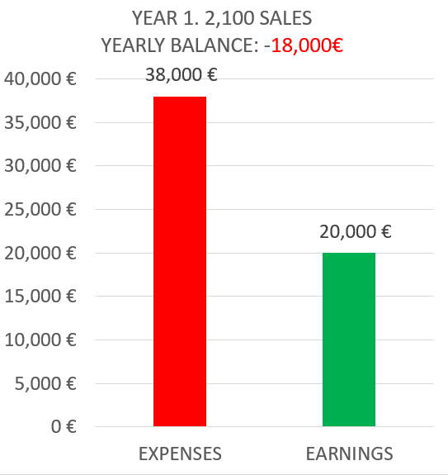

During the second year, we expect to keep selling our capsules at full price with some exception, such as discount campaigns. For this reason, we will assume that our total revenue will be about 90% of the price of the capsules sold. We need to take into account the costs of advertising, hosting and customer support, which will be the same as the previous year, which adds up to a total of 21,800 € to spend. On the other hand, we expect to double the sales of the first year, as we expect to have gained more traction in the market.

These are the estimations for our second year:

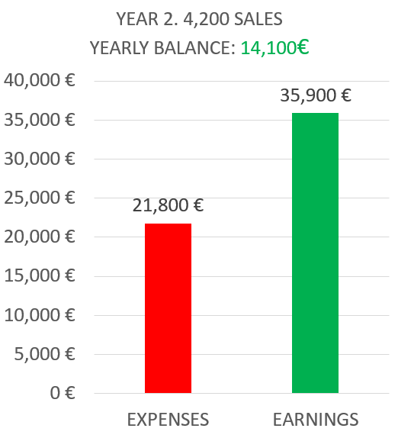

As for our third year, we expect our situation to change. Because at this point we have made back almost all the money invested, we will begin a more aggressive expansion plan. Our marketing department budget will be doubled, and in order to give service to a bigger amount of users, our maintenance costs will increase by 50%. With this strategy, we hope to reach 10K sales during this year, which will give us the following results:

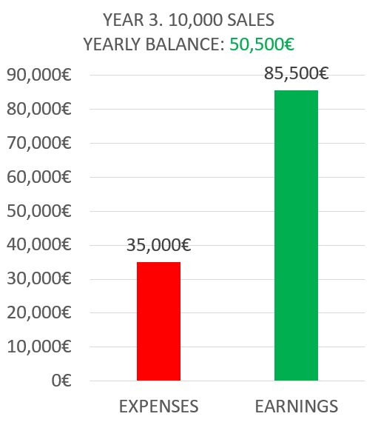

The progression of the profit that we expect to make along these first three years is the following:

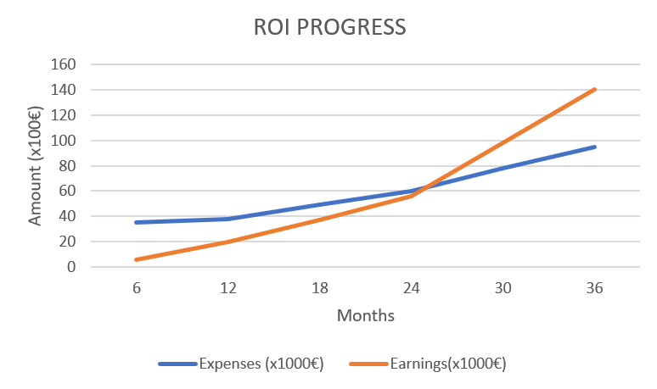

We can observer that we will recover the inversion made by the beginning of the third year. This is the reason why it was decided to start an expansion campaign, with more expenses.

# Investment analysis

At this point in time, the value of our product and the hours of work dedicated to its development is 35,000 €. This include the value of the hours invested and the expenses that were initially accounted for, such as customer support costs. These costs will be taken care of by the team behind this application, which means that we will not perceive any monetary compensation for the hours invested and that we will invest the 20K euros remaining of our initial budget. This leaves us with 55K € for which we need to find investors.

Our compromise with our investors is giving them back what they have invested +10% of the amount invested, which leaves us with nearly 60K euros to return. According to our estimations, we will be able to reach this amount by the end of the third year. Afterwards, investors will get a percentage of the business revenue based on the percentage of the cost of our product they have invested in.

As for the conditions we will impose to these investors, we will only ask that their invested amount is at least 500 euros per person.

In order to afford the initial 35,000€, we will ask a loan of 20K, as the other 15K can come out of our pockets so that we don’t need to pay unnecessary interest rates. If we do not manage to get enough investor to cover all our spendings, we will either ask for another loan or reduce the budget for our third year.